**+**

**St. Luke the Evangelist Catholic Church**

|  |  |  |
| --- | --- | --- |
| **6 August 2017**  **18th Sunday**  **in Ordinary Time**  **The Transfiguration of the Lord –Year A** | **Parish Administrator: *Fr. Dishan Candappa***  **School Principal: *Mrs Jackie Purcell***  **Parish Secretary: *Miss Marilyn Robert*** | **46 ORCHARD GROVE**  **PO BOX 2140**  BLACKBURN SOUTH 3130  Email: BlackburnSouth@cam.org.au  *PARISH Phone No: 9877 2292*  *SCHOOL Phone No: 98774023* |

## 

## **MASS TIMES**

**Week Days**

|  |  |  |
| --- | --- | --- |
| Monday | 9.00 AM | Mass |
| Tuesday | 11.00 AM | Mass |
| Wednesday | 9.00 AM | Mass |
| Wednesday | 7.30PM | Mass |
| Thursday | 9.00 AM | Mass |
| Friday | 9.00 AM | Mass |
| Saturday | 9.00 AM | Mass |

**Sundays**

Saturday Night Vigil Mass 6.00 PM

Sunday Mass 8.30 AM & 10.30 AM

**Reconciliation**

Saturday 9:30 AM / 5:30 PM

Wednesday – 6.30PM

Or by Appointment

**Adoration**

Wednesday – 6.30PM to 7.30pm

**Novena – Our Lady of Perpetual Help**

Wednesday – 7.00PM

## **COMMUNION MINISTERS ROSTER**

|  |  |  |  |  |  |  |  |  |
| --- | --- | --- | --- | --- | --- | --- | --- | --- |
|  |  | **5 and 6 Aug** | **12 and 13 Aug** | **5 and 6 Aug** | **29 and 30 July** | **22 and 23 July** | **1 and 2 July** | **17 and 18 June** |
| Saturday | 6:00 PM | Kathryn Holmes | Ian Holmes | Kathryn Holmes | Terry Wells | Olive Hammill | Olive Hammill | Monica Hodder |
| Sunday | 8:30 AM | Godfrey Thong | Melina Barcellona | Godfrey Thong | Beryl Chelliah | Kana Chelliah | Godfrey Thong | Beryl Chelliah |
|  | 10:30 AM | Margaret Gearon | Val Gardiner | Margaret Gearon | Sonya O’Farrell | Margaret Yore | Lizzie Dixon | Lynda Kilroe-Smith |

## **MINISTERS OF THE WORD ROSTER**

|  |  |  |  |
| --- | --- | --- | --- |
| Saturday | 6:00 PM | Ian Holmes | Kathryn Holmes |
| Sunday | 8:30 AM | Rosemary Donaldson | Jeanette Neumann |
|  | 10:30 AM | Choir/School | Elizabeth Dixon |
|  |  |  |  |

## **WELCOME ROSTER**

|  |  |  |  |
| --- | --- | --- | --- |
| Saturday | 6:00 PM | Lorraine Kermond | Greg Grant |
| Sunday | 8:30 AM | Joe Brogno | Marie Pekish |
|  | 10:30 AM | Margaret Gearon | Raymond Fung |
|  |  |  |  |

**SLIDE OPERATION**

|  |  |  |  |
| --- | --- | --- | --- |
| Saturday | 6:00 PM | David Prabha | Tony Lobo |
| Sunday | 8:30 AM | Megan McLean | Darren Mclean |
| **CHURCH FLOWERS**  12/8 – Jeanette Neumann | | **CHURCH CLEANING**  12/8 – Team 3  (Maree’s Team) | **MAINTENANCE**  12/8 – Team 2 (Dale Dixon & Ian Holmes)  26/8 – Team 3 (Sean Harford, Peter Fung) |

## 

[Type a quote from the document or the summary of an interesting point. You can position the text box anywhere in the document. Use the Drawing Tools tab to change the formatting of the pull quote text box.]

[Type a quote from the document or the summary of an interesting point. You can position the text box anywhere in the document. Use the Drawing Tools tab to change the formatting of the pull quote text box.]

**2. Pastoral Council Meeting – Postponed to 8 August –**

The next Parish Council Meeting will be held on 8 August at 7.30pm.

**3. Assumption Day Mass – 14th & 15th August**

Assumption Day is a Holy Day of obligation (like a Sunday). We will be having 4 Masses :

* 14 Aug – Monday 6pm (vigil)
* 15 Aug – Tuesday – 9am (school); 11am & 6pm.

**4. Baptisms**

Please pray for Matilda Christina Masters & Summer Grace Masters who will be baptised this Sunday.

**5. Adoration next Wednesday (9 Aug) – Euthanasia Bill**

Next Wednesday’s Adoration, 9 Aug, 6.30pm to 7.30pm will be specially dedicated to opposing the Euthanasia Bill.

**FEAST DAYS DURING THE WEEK**

**Tuesday, 8 Aug - SOLEMNITY - St. Mary of the Cross, virgin**

**Thursday, 10 Aug - FEAST – St. Lawrence, deacon, martyr**

**Friday, 11 Aug - MEMORIAL - St. Clare, virgin**

**NOTICES**

1. **Oppose Euthanasia Legislation – Letter Writing at Parish**

We will be having a Letter Writing campaign this Sunday, 6 August at the Parish Hall after the 10.30AM Mass, to oppose the Euthanasia legislation. We are invited to write personal, handwritten letters to 5 Upper House members of Parliament & 1 Lower House Member of Parliament of Forest Hill & surrounding area. Cuppa will be served. Please contact Debbie Brown on 0433 442 212 for more information.

Thank you.

**2. Special Collection next week – Catholic Care**

Special Collection is to promote the work of Catholic Care, helping disadvantaged families in our community.

**PLEASE CHECK T**HE NOTICEBOARD FOR ANY INFORMATION THAT MAY BE OF INTEREST TO YOU

*[Kindly do not place* ***any material on the Notice Board/Foyer Table without first asking permission]***

For Hall hire & inquiries phone –

9877 2292

Please send **NEWSLETTER NOTICES**

to the following e-mail address by ***Wednesday 5pm*** –

**BlackburnSouth@cam.org.au**

**Year of Mercy**

Pope Francis said he goes to confession every two weeks, knowing that God never tires of forgiving those who repent, but also knowing that having a priest say “I absolve you” reinforces belief in God’s mercy.

Using the literal Italian translation of a Spanish saying, “It’s better to turn red once than yellow a thousand times,” Pope Francis said he knows some people are embarrassed to confess their sins to a priest, but it is the best path to spiritual healing and health.

The only people God will not forgive are those who do not want God’s forgiveness, just like only those who stand in the shade are not warmed on a sunny day, Pope Francis said.

**Friday, 11 August – MEMORIAL - St. Clare of Assisi, virgin**

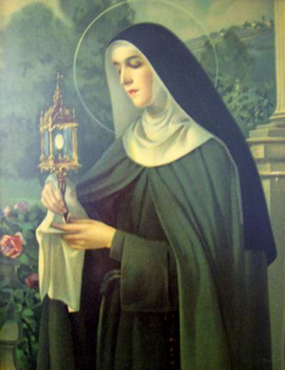

St. Clare of Assisi was born in Assisi on July 16, 1194. Clare joined the convent of the Benedictine nuns of San Paulo, under Francis' orders. In order to give her the greater solitude she desired, Francis sent Clare to Sant' Angelo in Panzo, another Benedictine nuns monastery.Following Francis' death, Clare continued to promote her order, fighting off every attempt from each pope trying to impose a rule on her order that would water down their "radical commitment to corporate poverty."In 1224, an army of rough soldiers from Frederick II came to attack Assisi. Although very sick, Clare went out to meet them with the Blessed Sacrament on her hands. She had the Blessed Sacrament placed at the wall where the enemies could see it. Then on her knees, she begged God to save the Sisters. "O Lord, protect these Sisters whom I cannot protect now," she prayed. A voice seemed to answer: "I will keep them always in My care." In that moment, a sudden fright struck the attackers and they fled as fast as they could without harming anyone in Assisi. St. Clare became sick and suffered great pains for many years, but she expressed that no pain could trouble her. So great was her joy in serving the Lord that she once exclaimed: "They say that we are too poor, but can a heart which possesses the infinite God be truly called poor?" Clare is often pictured carrying a monstrance or pyx, to commemorate the time she warded off the soldiers at the gates of her convent with the Blessed Sacrament.

*http://www.catholic.org/saints.php?saint_id=83*

**18th Sunday in Ordinary Time – Year A**

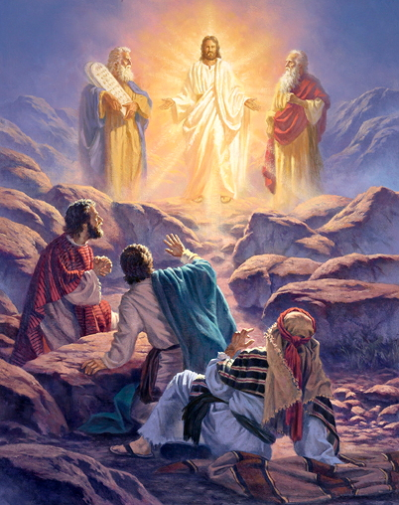

**Going up the mountain**

Jesus led His disciples , Peter, James and John, to Mount Tabor. There, on that mountain, each of them had a strong and deep experience of God’s presence. In the Bible, the mountain is a regular place of prayer where one encounters God deeply.

Today, Jesus leads us up the mountain to stay and deepen our relationship with Him. The normal reaction in many of us is we feel the need to ‘dod something during prayer time. Strangely, we say that we want to immerse ourselves in God’s presence and grow in our intimacy with Him. Yet, we allow ourselves to be distracted by being busy and doing things rather than to be still and listen atentively to Jesus. In today’s Gospel, Peter’s first reaction to the powerful vision was to do something. Instead of staying, keeping still and enjoying the deep experience of Jesus, Moses and Elijah conversing, he needed to go somewhere and do something. He understool that he simply needed to stop and listen when the voice from the clouds said, “This is my Son, the Beloved; he enjoys my favour. Listen to him’. There is a time to work. There is a time to pray. There is a time to do. There is a time to be still. Today, Jesus wants to bring us up the mountain in order to keep a distance from the busyness and noisiness of life. He leads us gently to immerse ourselves in God’s presence. It is time to simply stay still and listen to Jesus.

Reflection:

**What is Jesus’ invitation to me in this time of prayer ?**

*Source: ‘Prayer for Living-The Word of God for Daily Prayer Year A’, Sr. Sandra Seow, Verbum dei Missionaries, 2016.*

**Entrance Antiphon**

O God, come to my assistance;

O Lord, make haste to help me!

You are my rescuer, my help;

O Lord, do not delay.

**Responsorial Psalm**

The hand of the Lord feeds us, he answers all our needs.

**Gospel Acclamation**

Alleluia, alleluia!

No one lives on bread alone, but on every word that comes from the mouth of God.

Alleluia!

**Communion Antiphon**

You have given us O Lord, bread from heaven, endowed with all delights and sweetness in every taste.

**Readings of the week**

Sun 5 August **1st Reading** Isaiah 55:1-3; **Ps** 144:8-9,15-18.R.v.16; **2nd Reading** Romans 8:35,37-39; **Gospel: Matthew** 14:13-21

Sun 12 August **1st Reading** Kings 19:9,11-13**; Ps** 84: 9-14.R.v.8; **2nd Reading Romans** 9:1-5**;**  **Gospel: Matthew** 14: 22-33