**+**

**St. Luke the Evangelist Catholic Church**

|  |  |  |
| --- | --- | --- |
| **7 May 2017**  **4th SUNDAY of EASTER**  **Year A** | **Parish Administrator: *Fr. Dishan Candappa***  **Priest in Residence*: Fr. Zaher Mhanna***  **School Principal: *Mrs Jackie Purcell***  **Parish Secretary: *Miss Marilyn Robert*** | **46 ORCHARD GROVE**  **PO BOX 2140**  BLACKBURN SOUTH 3130  Email: BlackburnSouth@cam.org.au  *PARISH Phone No: 9877 2292*  *SCHOOL Phone No: 98774023* |

## 

## **MASS TIMES**

**Week Days**

|  |  |  |
| --- | --- | --- |
| Monday | 9.00 AM | Mass |
| Tuesday | 11.00 AM | Mass |
| Wednesday | 9.00 AM | Mass |
| Wednesday | 7.30PM | Mass |
| Thursday | 9.00 AM | Mass |
| Friday | 9.00 AM | Mass |
| Saturday | 9.00 AM | Mass |

**Sundays**

Saturday Night Vigil Mass 6.00 PM

Sunday Mass 8.30 AM & 10.30 AM

**Reconciliation**

Saturday 9:30 AM / 5:30 PM

Wednesday – 6.30PM

Or by Appointment

**Adoration**

Wednesday – 6.30PM to 7.30pm

**Novena – Our Lady of Perpetual Help**

Wednesday – 7.00PM

## **COMMUNION MINISTERS ROSTER**

|  |  |  |  |
| --- | --- | --- | --- |
|  |  | **6 and 7 May** | **13 and 14 May** |
| Saturday | 6:00 PM | Confirmation | Kathryn Holmes |
| Sunday | 8:30 AM | Melina Barcellona | Margaret Murphy |
|  | 10:30 AM | Lizzie Dixon | Val Gardiner |

## **MINISTERS OF THE WORD ROSTER**

|  |  |  |  |
| --- | --- | --- | --- |
| Saturday | 6:00 PM | Confirmation | Ian Holmes |
| Sunday | 8:30 AM | Robyn Marxsen | Jeanette Neumann |
|  | 10:30 AM | Kilroe-Smith Family | Jessica Kilroe-Smith |
|  |  |  |  |

## **WELCOME ROSTER**

|  |  |  |  |
| --- | --- | --- | --- |
| Saturday | 6:00 PM | - | Terry Wells |
| Sunday | 8:30 AM | Rosemary Donaldson | Don McKenzie |
|  | 10:30 AM | Judy Noy | Maureen McMahon |
|  |  | Lorraine Kermond |  |

**SLIDE OPERATION**

|  |  |  |  |
| --- | --- | --- | --- |
| Saturday | 6:00 PM | School Children | CHOIR |
| Sunday | 8:30 AM | Rosemary Donaldson | Darren McLean |
| **CHURCH FLOWERS**  13/5 - Joan McHugh  20/5 – Iris Evans &  Margaret McKenzie | | **CHURCH CLEANING**  13/5 – Team 9- Kathryn Woolridge, Melina Barcellona, Lucy Brown, Edith K. | **MAINTENANCE**  13/5 – Team 3  Joe Kam, Sean Harford & Peter Fung |

## 

[Type a quote from the document or the summary of an interesting point. You can position the text box anywhere in the document. Use the Drawing Tools tab to change the formatting of the pull quote text box.]

[Type a quote from the document or the summary of an interesting point. You can position the text box anywhere in the document. Use the Drawing Tools tab to change the formatting of the pull quote text box.]

**Children who received the Sacrament of Confirmation**



* ***Lachlan Blair - Caoimhe McCarthy***
* ***Jack Donlon - Matthew O’Malley***
* ***Margaret Hemsley - Will Parker***
* ***William Hemsley - James Robinson***
* ***Georgia Kelly - Kirra Stone***
* ***Natalia Leo - Jade Chan***
* ***Sienna Maccora - Jake Lethlean***
* ***Jacob Mazar - Michael Arrysandi***

**FEAST DAYS DURING THE WEEK**

**10th May – St. Damien of Molokai**

**13th May – Our Lady of Fatima**

**NOTICES**

1. **CONGRATULATIONS**

Congratulations to all 16 children who will be receiving the Sacrament of Confirmation this weekend. Let us continuously keep them in our prayers that they may be strengthened in their faith and joyfully bring Christ to others in their lives. We also thank their parents and teachers who have prepared them for this special day.



For Hall hire & inquiries phone –

9877 2292

Please send **NEWSLETTER NOTICES**

to the following e-mail address by ***Wednesday 5pm*** –

**BlackburnSouth@cam.org.au**

**PLEASE CHECK T**HE NOTICEBOARD FOR ANY INFORMATION THAT MAY BE OF INTEREST TO YOU

*[Kindly do not place* ***any material on the Notice Board/Foyer Table without first asking permission]***

**Year of Mercy**

Pope Francis said he goes to confession every two weeks, knowing that God never tires of forgiving those who repent, but also knowing that having a priest say “I absolve you” reinforces belief in God’s mercy.

Using the literal Italian translation of a Spanish saying, “It’s better to turn red once than yellow a thousand times,” Pope Francis said he knows some people are embarrassed to confess their sins to a priest, but it is the best path to spiritual healing and health.

The only people God will not forgive are those who do not want God’s forgiveness, just like only those who stand in the shade are not warmed on a sunny day, Pope Francis said.

**2. 100th Anniversary - Apparition of Our Lady of Fatima**

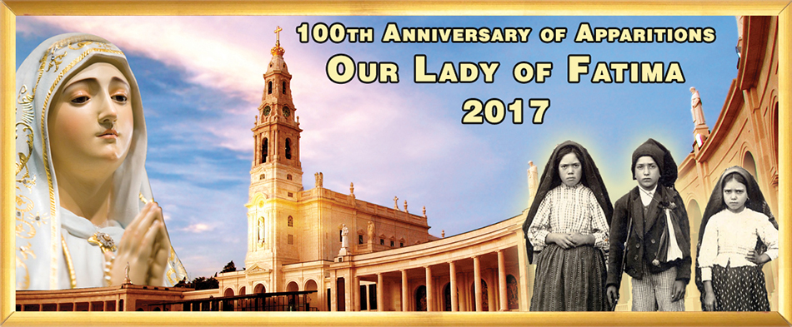

To mark the 100th Anniversary of the Apparition of Our Lady of Fatima, we will have a special hour of Adoration of the Blessed Sacrament from 3pm-4pm on Saturday, 13 May. We will begin with the recitation of the Divine Mercy Chaplet at 3pm, followed by the recitation of the Rosary, then Benediction. We will then conclude with light refreshments at the foyer. All are welcome.

**3. Guild of St. Stephen - Annual Mass**

The Annual Mass will be held on 26 May at 7.30pm at St. Patrick’s Cathedral. Archbishop Hart will be the Principal celebrant and will admit new members into the Guild. Any altar servers interested in becoming a member, please contact Fr. Dishan. (Closing date: 13 May 2017).

**4. Sisters from St Elisabeth Convent (Minsk, Belarus)**

Sisters from St Elisabeth Convent (Minsk, Belarus) are coming to our parish next Saturday, 13 May. They will offer souvenirs and church supplies made in their Convent. All proceeds will go to support facilities for children and adults with special needs as well as a rehabilitation centre for drug & alcohol addicts run by St Elisabeth Convent. Please welcome them & offer them your generous support.

**4th Sunday of Easter (Year A)**

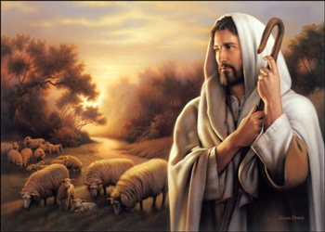**Bringing Jesus to people and people to Jesus**

‘What will you do with your life ? What are your plans ? Have you ever thought of committing your existence totally to Christ ? Do you think that there can be anything greater than to bring Jesus to people and people to Jesus ?’ (Pope John Paul II)

Today,we also celebrate Good Shepherd Sunday. It is a good opportunity to dialogue with the Shepherd about what we want to do with our life. Our life here on earth has a purpose-it is not to make lots of money or to have a successful career-but it is to ‘bring Jesus to people and people to Jesus’. Our Good Shepherd’s desire is that everyone hears his voice and follows Him. Today, Jesus wants us, as a parent, child, sibling, friend, employer, employee, citizen, etc. to be shepherds to those around us. We are here to ‘bring Jesus to people and people to Jesus’.

We cannot be shepherds if we ourselves are not familiar with the voice of our Good Shepherd and do not faithfully follow his footsteps each day. The message of Jesus for us today is : ‘Open your heart to my Love’. In our community, parishes, families, we need also to create the right environements that will help young people say ‘yes’ to God’s call. Let us also show our apprecaition to all those who have already given their ‘Yes’ to following Jesus as religious and priests.Let us pray for their faithfulness and fruitfulness.

As Christians, we are called to be Shepherds who will lead our family members, friends, community members, etc to Jesus! There is nothing that is greater than to bring Jesus to people and people to Jesus.

Reflection: **How can I bring Jesus to people and people to Jesus ?**

*Source: ‘Prayer for Living-The Word of God for Daily Prayer Year A’, Sr. Sandra Seow, Verbum dei Missionaries, 2016.*

*Source: ‘Prayer for Living-The Word of God for Daily Prayer Year A’, Sr. Sandra Seow, Verbum dei Missionaries, 2016.*

**Entrance Antiphon**

The merciful love of the Lord fills the earth;

by the word of the Lord the heavens were made, alleluia.

**Responsorial Psalm**

The Lord is my shepherd; there is nothing I shall want.

**Gospel Acclamation**

Alleluia, alleluia!

I am the good shepherd, says the Lord;

I know my own sheep and mine know me.

Alleluia!

**Communion Antiphon**

The Good Shepherd has risen,

who laid down his life for his sheep and

willingly died for his flock, alleluia.

**Readings of the week**

Sun 7 May **1st Reading** Zephaniah 2:3; 3:12-13 **Ps** 145:7-10 **2nd Reading**: Cor 1:26-31 **Gospel**: Matt 5:1-12

Sun 14 May **1st Reading** Acts of the Apostles 6: 1-7 **Ps** 32:1-2,4-5,18-19.R.v.22 **2nd Reading**: Peter 2:4-9 **Gospel**: John 14:1-12