Alcatel Lucent 8068 Handset – Quick Guide
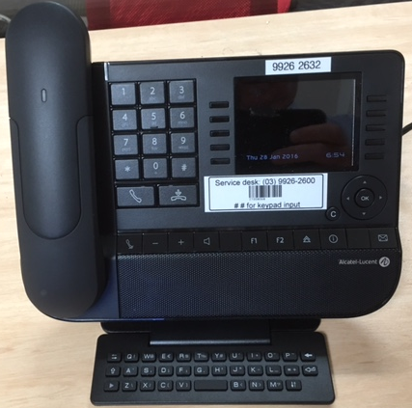

Full Phone no
Service Desk no
Bar Code
DTMF – e.g. Banking helpful tip

Keyboard input
( Dial by name or Initials )

SPEAKING HANDS FREE
 Press and release speaker icon.

HOW TO SET UP YOUR VOICEMAIL
 Press the mailbox button 
 Press Voicemail.
- The default voicemail password is 1234.
 Follow the prompts to listen to messages or change greeting message.

VOICEMAIL
 Flashing Blue light in the bottom right hand corner means you have a new message.
 Press the Mailbox button.
- Select the option “Voicemail”
- Enter your 4 digit password.

KEY NUMBERS:
CAM Reception: Dial 9
VMCH Reception: 2000

C
MAKING A CALL
External Dial 0 for an outside line,
followed by the number
Switch Dial 9 for Reception

TRANSFER
- When you need to transfer a call to another
destination
- Dial new number.
- Press Transfer.

CALL FORWARD
- To activate, go to Menu.
- Press Forward.
- Immediate VM.
- Press the key associated with the type
of call required.
- To cancel, go to Menu.
- Press Forward > Deactivate.

CHANGING THE VOLUME ON YOUR HANDSET
 Adjust audio volume 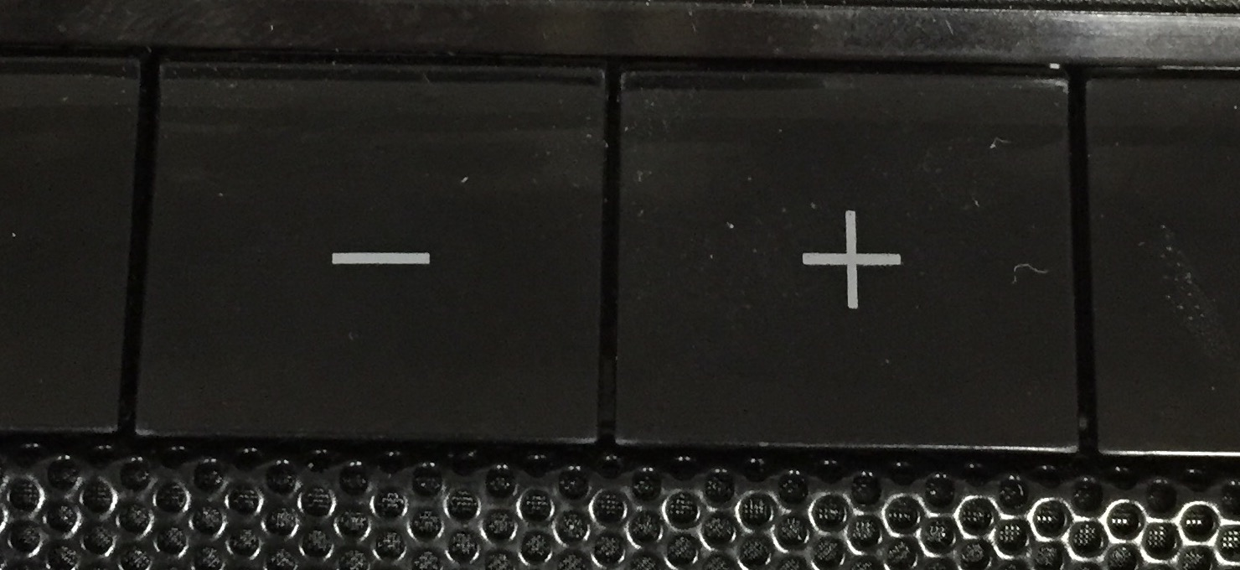

REDIAL
 Press redial button  to dial the last
external number dialed from your
handset or long press to access the
list of the last 10 dialed numbers.

Service Desk: (03) 9926 2600
Service.Desk@cam.org.au

