29

15th Sunday in Ordinary Time (A)

16th July AD2023

Liturgy of the Word
This week: Is 55:10-11 | Rom 8: 18-23 | Mt 13: 1-23
Resp Psalm: The seed that falls on good ground will yield a fruitful harvest.
Gospel Acclamation: Alleluia, Alleluia! The seed is the word of God, Christ is the sower; all who come to him will live for ever. Alleluia.
Next week: Wis 12:13, 16-19 | Rom 8: 26-27 | Mt 13: 24-43
________________________________________

______________________________________________
Corio & Lara
Catholic Parish
St Francis Xavier, Corio
St Anthony of Padua, Lara
Parish Office
143 Bacchus Marsh Rd Corio
Mon - Fri 9am—2pm
T. 03 4212 0791
E. fxcorio@iinet.net.au

Regular Mass Times
T. 9.15am Corio & 6pm Holy Hour
W. 9.15am Lara
Th. 9.15am Corio
F. 7.30am Corio
Sat 7pm (Vigil) Corio
Sun 9am Lara; 11am Corio
Confessions: 6pm Tues - Corio

First Saturdays
8.30 Confessions | 9.30 Mass
5.30pm Vietnamese Mass (Vigil)

Parish Team
Fr Daryl Montecillo PP | Pastor
Rev Royden D’Souza | Deacon
Arlean Alex | Parish Secretary
Connect with us!
@CorioLaraCatholic

________________________________________
Visiting Priest: A warm welcome to Fr Kerry Cronin who will be celebrating our masses with us this weekend.
Holy Communion to the Sick/Homebound: With an increasing need, we’ll be renewing this important ministry. If you are interested in joining this ministry or are currently bringing Holy Communion to the sick and homebound, please leave your details with the parish office. Guidance will be provided to ensure continuity for those being visited. Contact Dcn Royden with any queries.
Fr Daryl away: Fr Daryl leaves this Wed 19th July and will be back on deck on 19th August. Weekend masses will continue as usual with visiting priests but there will be no weekday masses.
Tuesday Holy Hour will continue as usual and a Holy Communion Service will be held on the first Saturday at 9.30am. See the notice in the foyers with nearby weekday mass times.
World Youth Day: Marnie and Darcey who we have been supporting head off for their pilgrimage this week. We continue to keep them in prayer as they will pray for all of us at the holy places.

Parish Sacramental Program
FIRST HOLY COMMUNION
Registrations are now open for our Parish Program.
Lessons will be held on Sundays commencing in
August. Please contact the Parish Office to register.

________________________________________

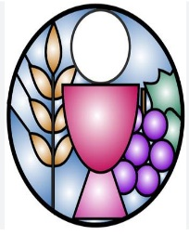

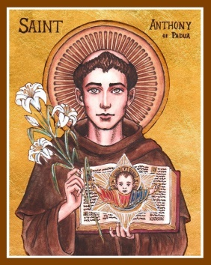
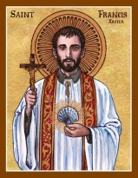
Parish Prayer List
Recent Deaths
Helen Nolan, Joyce Archer
Anniversaries
Norma Wilkie, Ricky Stolk
The Sick
Jessica De Grandis, John Thomas, Nicholas Francis, Bonnie Gilson, Ibi Boylos, Dee & Mark Tetzloft, Michael & Evan Watson, Stella Rani. Katarina & Michael Cabretti.

Pray for Seminarians! Pray for Vocations!
_________________________________

Next Weekend’s Mass Roster
7pm Corio | F Moloney (Reader)  A Randall (Commentator)  R Demicoli (EMHC)
9am Lara | R Vasquez ( Commentator )  B Hyland (Reader)  D Saliba (EMHC)
11am Corio | T Van Der Hoeven (Reader)  T Van Der Hoeven (Commentator)  V Neri & R Buaya (EMHC)
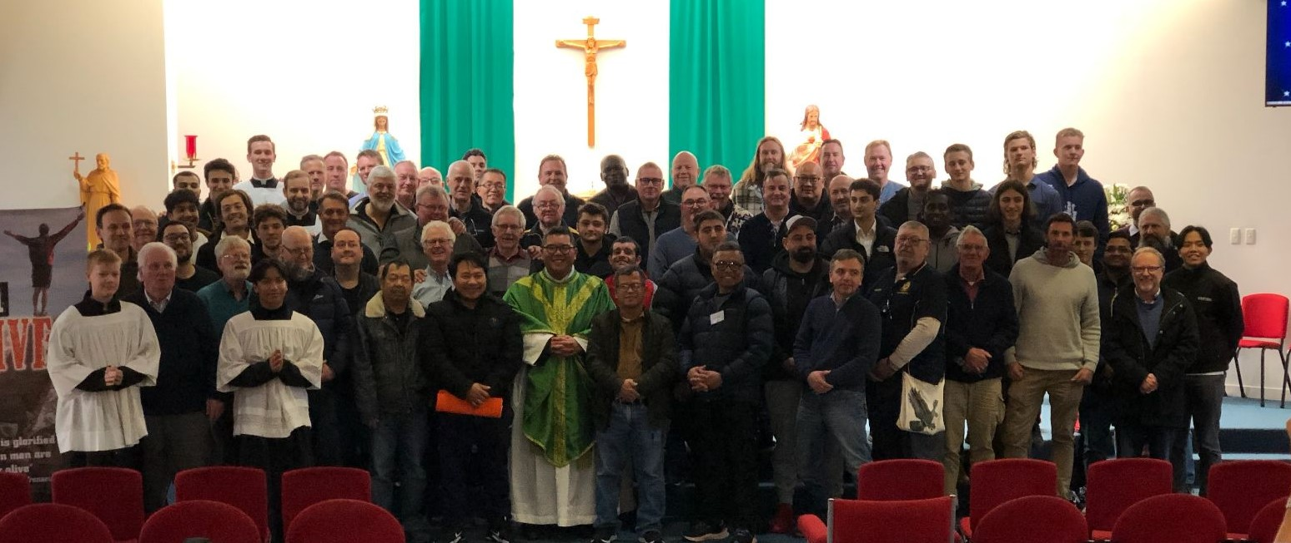
MenALIVE: THANK YOU!
Last weekend over ninety men from our parish and beyond participated in the MenALIVE weekend where they gathered to reflect on what makes them fully alive.

An immense thank you to our leadership team led by Martin Rowan, Shayne Lowther & Michael Neri, supported by Greg Beachell and Clarrie O’Shea who worked tirelessly behind the scenes leading up to an across the weekend to make it so successful.

Thanks also to all the attendees especially those who weren’t sure about it and took the plunge anyway. You’re an inspiration!
Church & School Addresses
St Francis Xavier: 143 Bacchus Marsh Rd. Corio | St Anthony of Padua: 90 Kees Rd. Lara
Our Parish is Committed to the Safety and Wellbeing of Children and Vulnerable Adults

