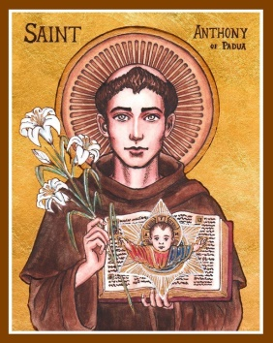
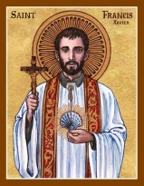
Corio & Lara Catholic Parish
St Francis Xavier, Corio | St Anthony of Padua, Lara
143 Bacchus Marsh Rd, Corio | 90 Kees Rd, Lara
Parish Office: 143 Bacchus Marsh Rd, Corio, VIC, 3214
T. 5275 4120 | E. corio@cam.org.au | W. pol.org.au/corio

Parish Administrator: Fr Daryl Montecillo

Parish Secretary: Arlean Alex
Regular Office Hours: Monday - Friday 9AM – 2PM

Sunday 13th September 2020
TWENTY FOURTH Sunday in Ordinary time

With our gifts we create a Parish that welcomes all people.

Communion Antiphon
How precious is your mercy, O God! The children of men seek shelter in the shadow of your wings.
Entrance Antiphon
Give peace, O Lord, to those who wait for you, that your prophets be found true. Hear the prayers of your servant, and of your people Israel.

This weekend’s readings have a striking message of forgiveness and justice and mercy. We forgive others because we recognise our need for it too. It’s not about perpetuating the ‘good old Catholic guilt’ but really leading to living out the golden rule of treating others the way want to be treated. We sometimes meet someone– or maybe experience it ourselves – who holds on to an old grudge or hurt. It never undoes the hurt that was received, but only causes more hurt in that person. Forgiveness instead frees not only those who have hurt us, but ourselves too. Forgiveness frees us to love. It frees us to live.
The lockdown situation is really frustrating. It might also be the cause of resentment and anger like the first reading speaks of. Our experiences and pain is real but it’s precisely these experiences of daily life that we’re invited to bring to God… to share them with God and each other. Our daily lives are where we can grow in holiness; grow in our friendship with God. I think this is what St Paul is getting at when he says that whether alive or dead, we belong to the Lord.
I had hoped, perhaps a bit ignorantly, that after these weeks of lockdown we’d just carry on where we left off six weeks ago. The Premier’s ‘roadmap to recovery’ is dependent on case numbers and so there is no concrete date on when we can gather together again to publicly celebrate our Faith together. At this stage, it looks like November at the earliest. It is very sad, but this is the situation we find ourselves in, and so it’s in this that we’re called to live and grow.
Parish offices in the Archdiocese must remain closed for now (with parish teams working from home) and we can’t all meet as we’d like, but one of the exemptions to lockdown is for pastoral care. If there’s anything that I can do to help you, please don’t hesitate to call me at the Office and we can sort something out. I’ll also look at increasing our parish’s website and phone capabilities so that we can better reach out to the community. Please allow me to also acknowledge and thank those who have prayed for as well as phoned/emailed/written to me personally and each other over these weeks. In these difficult weeks, God’s love is really shining through!
God bless you all!
Fr Daryl

LITURGY OF THE WORD
FIRST READING A reading from Ecclesiasticus 27:33-28:9

‘Forgive your neighbour the hurt he does you; and when you pray, your sins will be forgiven’
Resentment and anger, these are foul things, and both are found with the sinner. He who exacts vengeance will experience the vengeance of the Lord, who keeps strict account of sin. Forgive your neighbour the hurt he does you, and when you pray, your sins will be forgiven. If a man nurses anger against another, can he then demand compassion from the Lord? Showing no pity for a man like himself, can he then plead for his own sins? Mere creature of flesh, he cherishes resentment; who will forgive him his sins? Remember the last things, and stop hating, remember dissolution and death, and live by the commandments. Remember the commandments, and do not bear your neighbour ill-will; remember the covenant of the Most High, and overlook the offence. The Word of the Lord

RESPONSORIAL PSALM Ps 102
The Lord is compassion and love, slow to anger and rich in mercy.

SECOND READING A reading from the letter of St Paul to the Romans 14: 7-9

‘Alive or dead we belong to the Lord.’
The life and death of each of us has its influence on others; if we live, we live for the Lord; and if we die, we die for the Lord, so that alive or dead we belong to the Lord. This explains why Christ both died and came to life: it was so that he might be Lord both of the dead and of the living. The Word of the Lord

GOSPEL ACCLAMATION
Alleluia, Alleluia! Speak, Lord, your servant is listening: you have the message of eternal life. Alleluia!
GOSPEL A reading from the Holy Gospel according to Matthew 18: 21- 35

‘To be forgiven, you must forgive’

Peter went up to Jesus and said, ‘Lord, how often must I forgive my brother if he wrongs me? As often as seven times?’ Jesus answered, ‘Not seven, I tell you, but seventy-seven times. ‘And so the kingdom of heaven may be compared to a king who decided to settle his accounts with his servants. When the reckoning began, they brought him a man who owed ten thousand talents; but he had no means of paying, so his master gave orders that he should be sold, together with his wife and children and all his possessions, to meet the debt. At this, the servant threw himself down at his master’s feet. “Give me time” he said “and I will pay the whole sum.” And the servant’s master felt so sorry for him that he let him go and cancelled the debt. Now as this servant went out, he happened to meet a fellow servant who owed him one hundred denarii; and he seized him by the throat and began to throttle him. “Pay what you owe me” he said. His fellow servant fell at his feet and implored him, saying, “Give me time and I will pay you.” But the other would not agree; on the contrary, he had him thrown into prison till he should pay the debt. His fellow servants were deeply distressed when they saw what had happened, and they went to their master and reported the whole affair to him. Then the master sent for him. “You wicked servant,” he said “I cancelled all that debt of yours when you appealed to me. Were you not bound, then, to have pity on your fellow servant just as I had pity on you?” And in his anger the master handed him over to the torturers till he should pay all his debt. And that is how my heavenly Father will deal with you unless you each forgive your brother from your heart.’ The Gospel of the Lord

PARISH MISSION STATEMENT
We, the Catholic people of Corio & Lara Parish guided by the Spirit, participate in Christ’s Mission.
With our gifts we create a parish that welcomes all people.

Our Parish is committed to the safety, wellbeing and dignity of all children and vulnerable adults
Scripture Readings this week
Monday: Feast of the Exaltation of the Holy Cross: Philippians 2:6-11 & John 3:13-17
Tuesday: Memorial of Our Lady of Sorrows: Hebrews 5:7-9 & Luke 2:33-35
Wednesday: Memorial of Ss Cornelius and Cyprian: 1Corinthians 12:31-13:3 & Luke 7:31-35
Thursday: 1Corinthians 15:1-11 & Luke 7:36-50
Friday: 1Corinthians 15:12-20 & Luke 8:1-3
Saturday: 1Corinthians 15:35-37,42-49 & Luke 8:4-15

PARISH PRAYER
We, the people of Corio & Lara Catholic Parish give thanks and praise to God the Father. By the power of the Holy Spirit, may we become more like Jesus: listening to the Word of God and celebrating the Eucharist; sharing each other’s lives and forgiving one another; respecting creation and taking responsibility for our world.
Like St Francis Xavier, may we offer light to those in darkness, and warmly welcome all people.
Like St Anthony of Padua, may we nourish the hungry with wise words and kind deeds.
St Francis Xavier, pray for us.
St Anthony of Padua, pray for us.
Amen
________________________________________

Home Altar Supplies: A reminder that there is a small stand at the front door to the Parish House, where you can find bottles of holy water, rosaries and prayer cards, mass offering envelopes as well as hard copies of the bulletin. It’s available 7 days, from 9AM – 6PM. The latest bulletin goes out on Sundays.
Vocation View: Why is it that we lack real trust when the Lord calls us? We think we may drown, or have to give up too much, or fear failure. These attitudes can help to strengthen our faith in the Lord.
Pope’s Prayer Intention: We pray for all those who work and live from the sea, among them sailors, fishermen and their families.
As a community we pray for
Sick: Maria do ceu Fernandes, Jessica De Grandis, Victor Lombo, Vince Marshall, John Thomas, Judith
Cummins, Bill Rinaldi, Peter Franchina, Nicholas Francis, Bonnie Gilson, Mrs. Ibi Bolyos.
Anniversaries: Leo De Grandis
Recently Deceased: Ilham Rahemo, Ivan Loudas, Sue Sherman, Denise Kol

BULLETIN PRAYER INTENTIONS for any parishioners who are seriously ill, recently deceased or coming anniversaries: Please contact the Parish Office to include names in a future bulletin.
________________________________________
Thanksgiving Envelopes – Thank you to all who have been dropping their envelopes off at the Parish Office. While these are unprecedented times, please prayerfully consider if you are able to keep your pledges and contributions. Online donations are also available at the following: Ac. Name: St Francis Xavier Church BSB: 083347 Ac. No- 543292126 Thank you.

Parish Thanksgiving: Please consider joining the Parish Thanksgiving Programme. If you would like to join our new thanksgiving campaign, or to set up the thanksgiving by direct debit/ credit card please contact the parish office on 0352754120 or email fxcorio@iinet.net.au

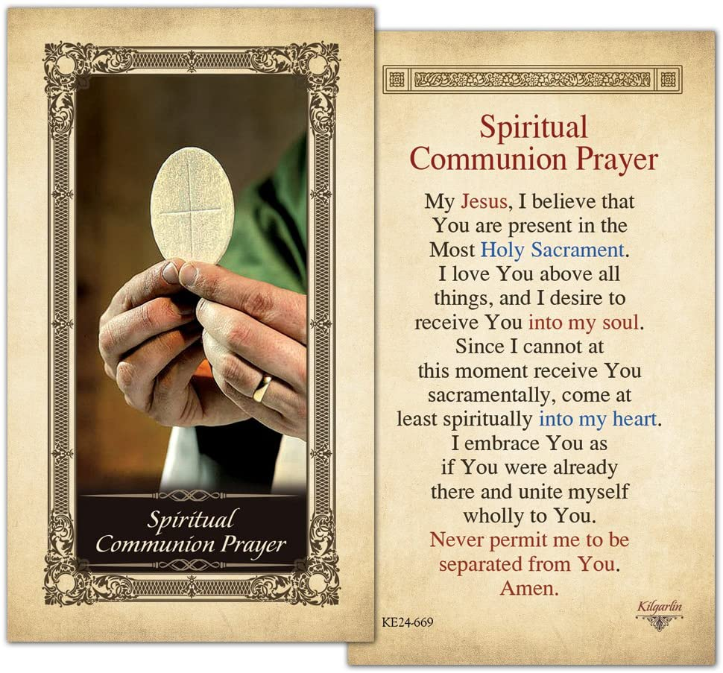

Kingsfunerals.com.au
Ph. 5248 3444

Icons in the header of our Parish Bulletin by Cecilia Lawrence

Our Parish Schools
St Francis Xavier, Corio
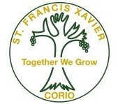
143 Bacchus Marsh Rd, Corio
Principal: Maria Scala
Ph. 5275 1974
principal@sfxcorio.catholic.edu.au
www.sfxcorio.catholic.edu.au

St Anthony of padua, lara
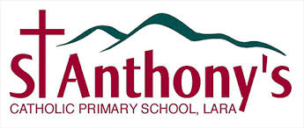

90 Kees Rd, Lara
Principal: Natalie Heard
Ph. 5282 1415
contactus@salara.catholic.edu.au
www.salara.catholic.edu.au/

Our Parish is committed to the safety, wellbeing and dignity of all children and vulnerable adults

