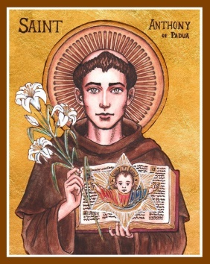
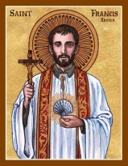
Corio & Lara Catholic Parish
St Francis Xavier, Corio | St Anthony of Padua, Lara
143 Bacchus Marsh Rd, Corio | 90 Kees Rd, Lara
Parish Office: 143 Bacchus Marsh Rd, Corio, VIC, 3214
T. 5275 4120 | E. corio@cam.org.au | W. pol.org.au/corio

Parish Administrator: Fr Daryl Montecillo

Parish Secretary: Arlean Alex
Regular Office Hours: Monday - Friday 9AM – 2PM

Sunday 23rd August 2020
TWENTY FIRST Sunday in Ordinary time

With our gifts we create a Parish that welcomes all people.

Communion Antiphon
The earth is replete with the fruits of your work, O Lord; you bring forth bread from the earth and wine to cheer the heart.

Entrance Antiphon
Turn your ear, O Lord, and answer me; save the servant who trusts in you, my God. Have mercy on me, O Lord, for I cry to you all the day long.

How have these weeks of lockdown been treating you?

I’m sure there are a whole range of emotions and experiences as we figure out this new normal (nothing normal about it!). Perhaps there’s disbelief and frustration, anger even. Maybe there’s a relief that we can somewhat step back, or a loneliness and isolation from being separated from loved ones. Whatever they are, this weekend’s readings can offer comfort, remembering that all of this is in God’s hands. Not just pandemic viruses or issues on a worldwide scale, but also the little things that might trouble your heart, things that no one else knows about. God does, and he cares, about them and about you! To help us get through the struggles of life he gives us the family of the Church, his family, which as a structure is beginning to be formed in the mysterious event in the gospel, as the Lord shares his authority with St Peter.
We can really rejoice with St Paul in the Second Reading saying “How rich are the depths of God.”

Later this week there are also the feasts of St Monica (Thursday) and her son St Augustine (Friday). As you may know, Augustine lived a bit of a wild life in his younger days. Monica went to a priest, upset that Augustine never listened or cared about something so important. The priest suggested: ‘spend more time talking to God about Augustine, than talking to Augustine about God.’ It was St Monica’s prayers and struggles that brought about her son’s conversion. It’s something I remember any time I get anxious about someone who has stepped away from their faith (not just because of lockdowns). Maybe you might know someone who is in a similar position. We can do the same… showing them God’s love and speaking to God about them.

Thank you all once again for showing me and each other God’s love. Let’s pray for each other.
Fr Daryl

PARISH MISSION STATEMENT
We, the Catholic people of Corio & Lara Parish guided by the Spirit, participate in Christ’s Mission.
With our gifts we create a parish that welcomes all people.

Our Parish is committed to the safety, wellbeing and dignity of all children and vulnerable adults

LITURGY OF THE WORD
FIRST READING A reading from prophet Isaiah 22: 19- 23

‘I place the key of the house of David on my servants shoulder’

Thus says the Lord of Hosts to Shebna, the master of the palace: I dismiss you from your office, I remove you from your post, and the same day I call on my servant Eliakim son of Hilkiah. I invest him with your robe, gird him with your sash, entrust him with your authority; and he shall be a father to the inhabitants of Jerusalem and to the House of Judah. I place the key of the House of David on his shoulder; should he open, no one shall close, should he close, no one shall open. I drive him like a peg into a firm place; he will become a throne of glory for his father’s house. The Word of the Lord

RESPONSORIAL PSALM Ps 137: 1-3, 6, 8
Your love, O Lord, is eternal, discard not the work of your hands.

SECOND READING A reading from the letter of St Paul to the Romans 11: 33- 36

‘All that exists comes from him; all is by him and from him.’

How rich are the depths of God – how deep his wisdom and knowledge – and how impossible to penetrate his motives or understand his methods! Who could ever know the mind of the Lord? Who could ever be his counsellor? Who could ever give him anything or lend him anything? All that exists comes from him; all is by him and for him. To him be glory for ever! Amen. The Word of the Lord

GOSPEL ACCLAMATION
Alleluia, Alleluia! God in Christ was reconciling the world to himself, and he has entrusted to us the news that they are reconciled. Alleluia!
GOSPEL A reading from the Holy Gospel according to Matthew 16: 13- 20

‘You are Peter and on this rock I will build my Church’

When Jesus came to the region of Caesarea Philippi he put this question to his disciples, ‘Who do people say the Son of Man is?’ And they said, ‘Some say he is John the Baptist, some Elijah, and others Jeremiah or one of the prophets.’ ‘But you,’ he said ‘who do you say I am?’ Then Simon Peter spoke up, ‘You are the Christ,’ he said, ‘the Son of the living God.’ Jesus replied, ‘Simon son of Jonah, you are a happy man! Because it was not flesh and blood that revealed this to you but my Father in heaven. So I now say to you: You are Peter and on this rock I will build my Church. And the gates of the underworld can never hold out against it. I will give you the keys of the kingdom of heaven: whatever you bind on earth shall be considered bound in heaven; whatever you loose on earth shall be considered loosed in heaven.’ Then he gave the disciples strict orders not to tell anyone that he was the Christ. The Gospel of the Lord
Scripture Readings this week
Monday: Feast of St Bartholomew: Revelation 21:9-14 & John 1:45-51
Tuesday: 2Thessalonians 2:1-3,14-17 & Matthew 23:23-26
Wednesday: 2Thessalonians 3:6-10,6-18 & Matthew 23:27-32
Thursday: Memorial of St Monica: Sirach 26:1-4,13-16 & Luke 7:11-17
Friday: Memorial of St Augustine: 1John 4:7-16 & Matthew 23:8-12
Sat: Memorial of the Passion of St John the Baptist: Jeremiah 1:17-19 & Mark 6:17-29

PARISH PRAYER
We, the people of Corio & Lara Catholic Parish give thanks and praise to God the Father. By the power of the Holy Spirit, may we become more like Jesus: listening to the Word of God and celebrating the Eucharist; sharing each other’s lives and forgiving one another; respecting creation and taking responsibility for our world.
Like St Francis Xavier, may we offer light to those in darkness, and warmly welcome all people.
Like St Anthony of Padua, may we nourish the hungry with wise words and kind deeds.
St Francis Xavier, pray for us.
St Anthony of Padua, pray for us.
Amen
________________________________________

Vocation View: Why is it that we lack real trust when the Lord calls us? We think we may drown, or have to give up too much, or fear failure. These attitudes can help to strengthen our faith in the Lord.
Pope’s Prayer Intention: We pray for all those who work and live from the sea, among them sailors, fishermen and their families.
As a community we pray for
Sick: Maria do ceu Fernandes, Jessica De Grandis, Victor Lombo, Vince Marshall, John Thomas, Judith
Cummins, Bill Rinaldi, Peter Franchina, Nicholas Francis, Bonnie Gilson, Mrs. Ibi Bolyos.
Recently Deceased: Ilham Abdulraheem Rahemo, Sue Sherman.

BULLETIN PRAYER INTENTIONS for any parishioners who are seriously ill, recently deceased or coming anniversaries: Please contact the Parish Office to include names in a future bulletin.
________________________________________

Parish Facilities: With the latest restrictions both churches, as well as the Ron Lowe Room and the Xavier Centre are closed for public use. Apologies for any inconvenience and thank you for understanding.
Thanksgiving Envelopes – Thank you to all who have been dropping their envelopes off at the Parish Office. While these are unprecedented times, please prayerfully consider if you are able to keep your pledges and contributions. Online donations are also available at the following: Ac. Name: St Francis Xavier Church BSB: 083347 Ac. No- 543292126 Thank you.
Parish Thanksgiving: Please consider joining the Parish Thanksgiving Programme. If you would like to join our new thanksgiving campaign, or to set up the thanksgiving by direct debit/ credit card please contact the parish office on 0352754120 or email fxcorio@iinet.net.au

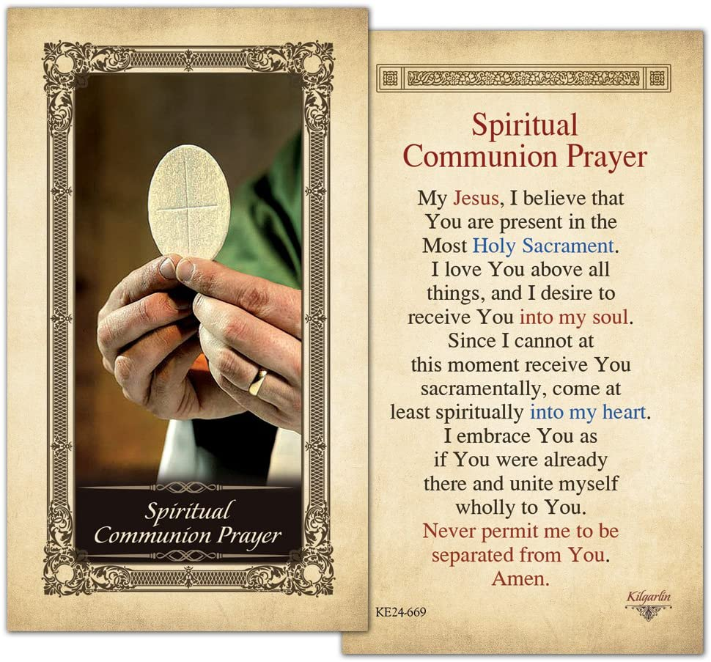

kingsfunerals.com.au
Ph 5248 3444

Icons in the header of our Parish Bulletin by Cecilia Lawrence

Our Parish Schools
St Francis Xavier, Corio
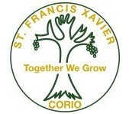
143 Bacchus Marsh Rd, Corio
Principal: Maria Scala
Ph. 5275 1974
principal@sfxcorio.catholic.edu.au
www.sfxcorio.catholic.edu.au

St Anthony of padua, lara
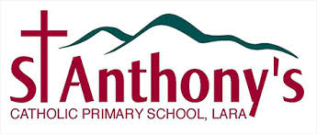

90 Kees Rd, Lara
Principal: Natalie Heard
Ph. 5282 1415
contactus@salara.catholic.edu.au
www.salara.catholic.edu.au/

Our Parish is committed to the safety, wellbeing and dignity of all children and vulnerable adults

