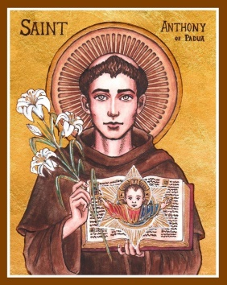
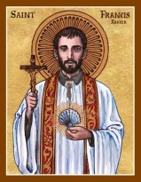
Corio & Lara Catholic Parish
St Francis Xavier, Corio | St Anthony of Padua, Lara
143 Bacchus Marsh Rd, Corio | 90 Kees Rd, Lara
Parish Office: 143 Bacchus Marsh Rd, Corio, VIC, 3214
T. 5275 4120 | E. corio@cam.org.au | W. pol.org.au/corio

Parish Administrator: Fr Daryl Montecillo

Parish Secretary: Arlean Alex
Office Hours: Monday - Friday 9AM – 2PM

Sunday 2nd August 2020
EIGHTEENTH Sunday in Ordinary time

With our gifts we create a Parish that welcomes all people.

Communion Antiphon
You have given us, O Lord, bread from heaven, endowed with all delights and sweetness in every taste.

With our gifts we create a Parish that welcomes all people.
Entrance Antiphon
O God, come to my assistance; O Lord make haste to help me! You are my rescuer, my help; O Lord, do not delay.

With our gifts we create a Parish that welcomes all people.

Masses continuing for now with some changes
With the latest restrictions now including Greater Geelong, our Parish has to make a few changes regarding our public masses and liturgies. From tomorrow (Monday), all who attend any mass or liturgy must wear a facemask. This is a both a government directive and a requirement of the Parish. Mass will not begin if someone refuses to wear a mask.
In line with Archdiocesan protocols, Readers may lower their mask once at the lectern for the Readings /Prayers of the Faithful, but must replace it before returning to their seat. These protocols will be displayed in the church if you wish to see them.
As it is now quite impractical, from next weekend, we will also pause our singing at masses for the time being.
Wearing masks is a confronting reminder of how close and real the risk of infection is. Please remember that if you are feeling unwell or particularly vulnerable, please stay home.
At the time of writing, we are still waiting for any major decisions regarding lockdowns or the suspension of masses. For now we’ll continue slowly as we have been and will update you as soon as we know anything further.
The readings, and in fact all the texts at mass this weekend, are a timely and beautiful reminder that everything is in the hands of God. The pandemic is truly frightening and all seems very close to home now, but nothing can separate us from the love of God. Nothing. So let’s keep trusting in our loving God and looking after each other.
PARISH MISSION STATEMENT
We, the Catholic people of Corio & Lara Parish guided by the Spirit, participate in Christ’s Mission.
With our gifts we create a parish that welcomes all people.

Our Parish is committed to the safety, wellbeing and dignity of all children and vulnerable adults

LITURGY OF THE WORD
FIRST READING A reading from the prophet Isaiah 55: 1-3

‘Come and Eat’
Thus says the Lord: Oh, come to the water all you who are thirsty; though you have no money, come! Buy corn without money, and eat, and, at no cost, wine and milk. Why spend money on what is not bread, your wages on what fails to satisfy? Listen, listen to me, and you will have good things to eat and rich food to enjoy. Pay attention, come to me; listen, and your soul will live. With you I will make an everlasting covenant out of the favours promised to David. The Word of the Lord

RESPONSORIAL PSALM Ps 144: 8-9, 15-18
The hand of the Lord feeds us: he answers all our needs.

SECOND READING A reading from the letter of St Paul to the Romans 8: 3

‘No created thing can ever come between us and the love of God made visible in Christ’

Nothing can come between us and the love of Christ, even if we are troubled or worried, or being persecuted, or lacking food or clothes, or being threatened or even attacked. These are the trials through which we triumph, by the power of him who loved us. For I am certain of this: neither death nor life, no angel, no prince, nothing that exists, nothing still to come, not any power, or height or depth, nor any created thing, can ever come between us and the love of God made visible in Christ Jesus our Lord.
The Word of the Lord

GOSPEL ACCLAMATION
Alleluia, Alleluia! No one lives on bread alone but from every word that comes from the mouth of God. Alleluia!
GOSPEL A reading from the Holy Gospel according to Matthew 14: 13- 21

‘The feeding of the five thousand’

When Jesus received the news of John the Baptist’s death he withdrew by boat to a lonely place where they could be by themselves. But the people heard of this and, leaving the towns, went after him on foot. So as he stepped ashore he saw a large crowd; and he took pity on them and healed their sick. When evening came, the disciples went to him and said, ‘This is a lonely place, and the time has slipped by; so send the people away, and they can go to the villages to buy themselves some food.’ Jesus replied, ‘There is no need for them to go: give them something to eat yourselves.’ But they answered ‘All we have with us is five loaves and two fish.’ ‘Bring them here to me’ he said. He gave orders that the people were to sit down on the grass; then he took the five loaves and the two fish, raised his eyes to heaven and said the blessing. And breaking the loaves handed them to his disciples who gave them to the crowds. They all ate as much as they wanted, and they collected the scraps remaining; twelve baskets full. Those who ate numbered about five thousand men, to say nothing of women and children.
The Gospel of the Lord
Liturgy this Week
Tuesday: Memorial of St John Vianney 9:15 Mass & 5:30 Holy Hour with confessions (Corio)
Wednesday: Memorial of St Martha: 9:15 Mass (Lara)
Thursday: Feast of the Transfiguration 9:15 Mass (Corio)
Friday: 9:15 Mass (Lara)
Saturday: 7PM Vigil (Corio)
Sunday: 9AM (Lara) & 11AM (Corio)

PARISH PRAYER
We, the people of Corio & Lara Catholic Parish give thanks and praise to God the Father. By the power of the Holy Spirit, may we become more like Jesus: listening to the Word of God and celebrating the Eucharist; sharing each other’s lives and forgiving one another; respecting creation and taking responsibility for our world.
Like St Francis Xavier, may we offer light to those in darkness, and warmly welcome all people.
Like St Anthony of Padua, may we nourish the hungry with wise words and kind deeds.
St Francis Xavier, pray for us.
St Anthony of Padua, pray for us.
Amen
________________________________________

Vocation View: If some people did not hoard the riches of this world, all people would have enough to eat and drink. Too many people starve to death every day. Who will speak loudly of justice today?
Pope’s Prayer Intention: We pray for all those who work and live from the sea, among them sailors, fishermen and their families.
As a community we pray for
Sick: Maria do ceu Fernandes, Jessica De Grandis, Victor Lombo, Vince Marshall, John Thomas, Judith
Cummins, Bill Rinaldi, Peter Franchina, Nicholas Francis, Bonnie Gilson, Mrs. Ibi Bolyos.
Anniversaries: David Demicoli & Mark Demicoli
Recently Deceased: Joan Marshall, Peter Murphy, Domingo Quiamco Sr.

NAMES OF RECENT DEATHS & ANNIVERSARIES, and the UNWELL IN OUR PARISH FOR THE BULLETIN We still accept the names of those Recently Deceased, Anniversary of Death and the names of those who are sick within our Parish. Please call the Office on: 52754120 or email: fxcorio@iinet.net.au
________________________________________

St Francis Xavier Centre: During this challenging time, we advise the Parishioners not to use the Francis Xavier hall. At present the hall is booked by St Francis Xavier school and is used only by the school.
Thanksgiving Envelopes – Thank you to all who have been dropping their envelopes off at the Parish Office. The Office is open Monday - Friday from 9:00- 2:00. While these are unprecedented times, please prayerfully consider if you are able to keep your pledges and contributions. Online donations are also available at the following: Ac. Name: St Francis Xavier Church BSB: 083347 Ac. No- 543292126 Thank you.
Parish Thanksgiving: Please consider joining the Parish Thanksgiving Programme. If you would like to join our new thanksgiving campaign, or to set up the thanksgiving by direct debit/ credit card please contact the parish office on 0352754120 or email fxcorio@iinet.net.au

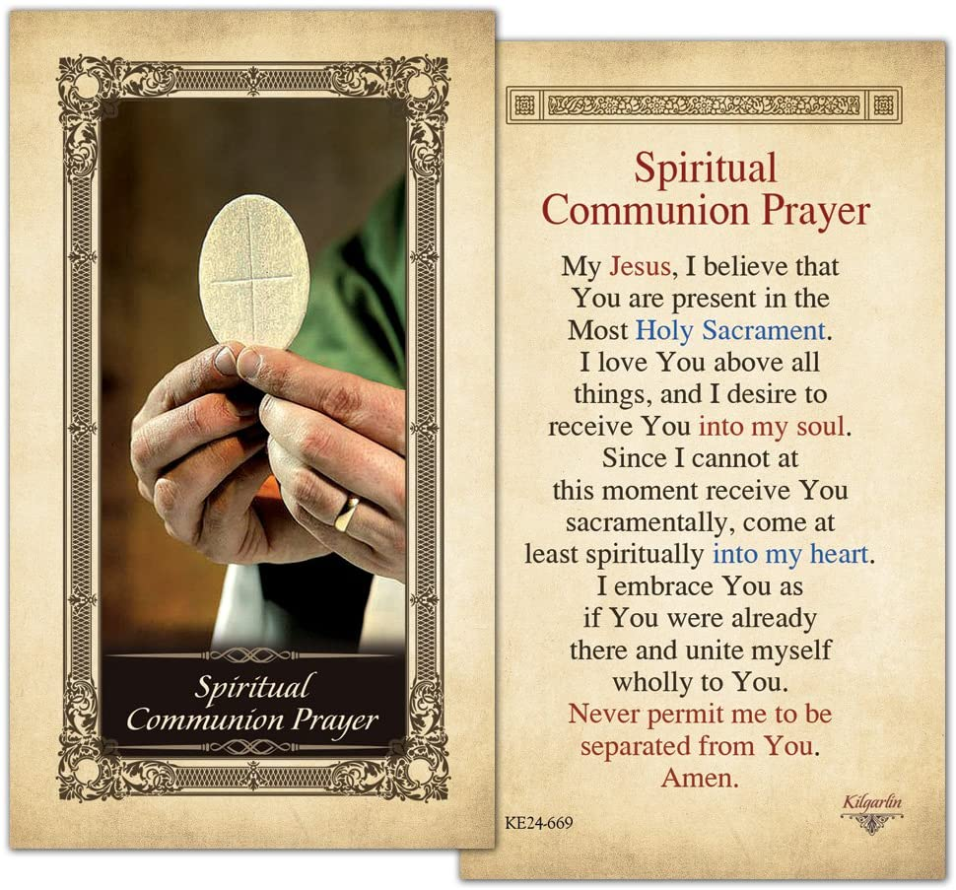

kingsfunerals.com.au
Ph 5248 3444

Icons in the header of our Parish Bulletin by Cecilia Lawrence

Our Parish Schools
St Francis Xavier, Corio
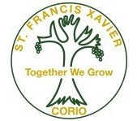
143 Bacchus Marsh Rd, Corio
Principal: Maria Scala
Ph. 5275 1974
principal@sfxcorio.catholic.edu.au
www.sfxcorio.catholic.edu.au

St Anthony of padua, lara
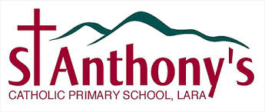

90 Kees Rd, Lara
Principal: Natalie Heard
Ph. 5282 1415
contactus@salara.catholic.edu.au
www.salara.catholic.edu.au/

Our Parish is committed to the safety, wellbeing and dignity of all children and vulnerable adults

