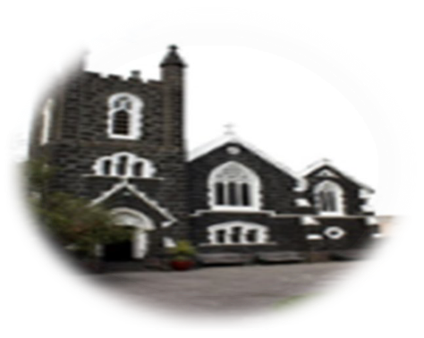

The Most Holy Body and Blood of Christ 2nd Jun 2024
First reading: Exodus 24:3-8
Moses went and told the people all the commands of the Lord and all the ordinances. In answer, all the people said with one voice, ‘We will observe all the commands that the Lord has decreed.’ Moses put all the commands of the Lord into writing, and early next morning he built an altar at the foot of the mountain, with twelve standing-stones for the twelve tribes of Israel. Then he directed certain young Israelites to offer holocausts and to immolate bullocks to the Lord as communion sacrifices. Half of the blood Moses took up and put into basins, the other half he cast on the altar. And taking the Book of the Covenant he read it to the listening people, and they said, ‘We will observe all that the Lord has decreed; we will obey.’ Then Moses took the blood and cast it towards the people. ‘This,’ he said, ‘is the blood of the Covenant that the Lord has made with you, containing all these rules.’
Responsorial Psalm:
Psalm 115(116):12‐13,15‐18:
I will take the cup of salvation, and call on the name of the Lord.
How can I repay the Lord for his goodness to me? The cup of salvation I will raise; I will call on the Lord’s name.
I will take the cup of salvation, and call on the name of the Lord.
Oh precious in the eyes of the Lord is the death of his faithful. Your servant, Lord, your servant am I; you have loosened my bonds.
I will take the cup of salvation, and call on the name of the Lord.
A thanksgiving sacrifice I make; I will call on the Lord’s name. My vows to the Lord I will fulfil before all his people.
I will take the cup of salvation, and call on the name of the Lord.
Second Reading: Hebrews 9:11-15
Now Christ has come, as the high priest of all the blessings which were to come. He has passed through the greater, the more perfect tent, which is better than the one made by men’s hands because it is not of this created order; and he has entered the sanctuary once and for all, taking with him not the blood of goats and bull calves, but his own blood, having won an eternal redemption for us. The blood of goats and bulls and the ashes of a heifer are sprinkled on those who have incurred defilement and they restore the holiness of their outward lives; how much more effectively the blood of Christ, who offered himself as the perfect sacrifice to God through the eternal Spirit, can purify our inner self from dead actions so that we do our service to the living God. He brings a new covenant, as the mediator, only so that the people who were called to an eternal inheritance may actually receive what was promised: his death took place to cancel the sins that infringed the earlier covenant.
Sequence: Lauda, Sion
Gospel Acclamation: John 6:51-52
Alleluia, alleluia!
I am the living bread from heaven, says the Lord; whoever eats this bread will live for ever.
Alleluia!
Gospel: Mark 14:12-16,22-26
On the first day of Unleavened Bread, when the Passover lamb was sacrificed, his disciples said to Jesus, ‘Where do you want us to go and make the preparations for you to eat the passover?’ So he sent two of his disciples, saying to them, ‘Go into the city and you will meet a man carrying a pitcher of water. Follow him, and say to the owner of the house which he enters, “The Master says: Where is my dining room in which I can eat the passover with my disciples?” He will show you a large upper room furnished with couches, all prepared. Make the preparations for us there.’ The disciples set out and went to the city and found everything as he had told them, and prepared the Passover. And as they were eating he took some bread, and when he had said the blessing he broke it and gave it to them. ‘Take it,’ he said ‘this is my body.’ Then he took a cup, and when he had returned thanks he gave it to them, and all drank from it, and he said to them, ‘This is my blood, the blood of the covenant, which is to be poured out for many. I tell you solemnly, I shall not drink any more wine until the day I drink the new wine in the kingdom of God.’ After psalms had been sung they left for the Mount of Olives.
The Gospel of the Lord
ROSTER :
10.30am Sunday:
Priest: Mons. Stuart Hall ; Readers: Felicia, Jennifer MOC: Heather; Altar Servers: Natasya, Jeslyn, Elvin, McDony
8pm Sunday: Reader: Imelda
Mass times: Tu, Wed, Fri at 1.05pm; Sun at 10.30am and 8pm; Confession: Wed. 12.30pm-12.50pm
Why not join us for coffee after mass
FIAT- WEEKEND OF PRAYER
TODAY Sunday 2nd June:
Mass at Sacred Heart Church Carlton -1pm followed by the Eucharist Procession at 2.30pm to St Patrick’s Cathedral concluding with Afternoon Prayer and Benediction

Your Financial support makes a difference. In fact, planned giving helps us fund necessary church projects.
St Augustine’s currently needs long overdue renovations and upgrades. Being a heritage-listed building, renovations are strictly regulated by specific guidelines, which costs money. Consider weekly electronic giving by filling out a stewardship card or scan the QR code to download the Parousya Faith App and choose St Augustine’s to donate. Together, we can hit our goals!
