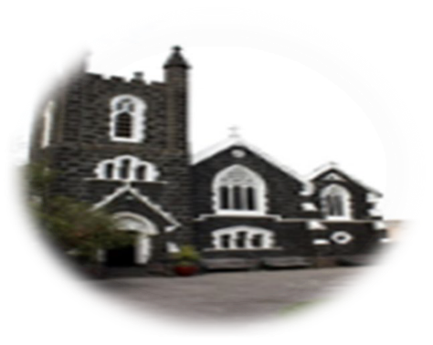

15th SUNDAY IN ORDINARY TIME th 14th July 2024

**First reading: Amos 7:12-15**

Amaziah, the priest of Bethel, said to Amos, ‘Go away, seer;’ get back to the land of Judah; earn your bread there, do your prophesying there. We want no more prophesying in Bethel; this is the royal sanctuary, the national temple.’ ‘I was no prophet, neither did I belong to any of the brotherhoods of prophets,’ Amos replied to Amaziah ‘I was a shepherd, and looked after sycamores: but it was the Lord who took me from herding the flock, and the Lord who said, “Go, prophesy to my people Israel.”’

**Responsorial Psalm: Psalm 84(85):9-14**

*Lord, show us your mercy and love, and grant us your salvation.*

I will hear what the Lord God has to say, a voice that speaks of peace, peace for his people. His help is near for those who fear him and his glory will dwell in our land.

*Lord, show us your mercy and love, and grant us your salvation.*

Mercy and faithfulness have met; justice and peace have embraced. Faithfulness shall spring from the earth and justice look down from heaven.

*Lord, show us your mercy and love, and grant us your salvation.*

The Lord will make us prosper and our earth shall yield its fruit Justice shall march before him and peace shall follow his steps.

*Lord, show us your mercy and love, and grant us your salvation*.

**Second Reading: Ephesians 1:3-14**

Blessed be God the Father of our Lord Jesus Christ, who has blessed us with all the spiritual blessings of heaven in Christ.

Before the world was made, he chose us, chose us in Christ, to be holy and spotless, and to live through love in his presence, determining that we should become his adopted sons, through Jesus Christ for his own kind purposes, to make us praise the glory of his grace, his free gift to us in the Beloved, in whom, through his blood, we gain our freedom, the forgiveness of our sins. Such is the richness of the grace which he has showered on us in all wisdom and insight. He has let us know the mystery of his purpose, the hidden plan he so kindly made in Christ from the beginning to act upon when the times had run their course to the end: that he would bring everything together under Christ, as head, everything in the heavens and everything on earth.

And it is in him that we were claimed as God’s own, chosen from the beginning, under the predetermined plan of the one who guides all things

as he decides by his own will; chosen to be, for his greater glory, the people who would put their hopes in Christ before he came. Now you too, in him, have heard the message of the truth and the good news of your salvation, and have believed it; and you too have been stamped with the seal of the Holy Spirit of the Promise, the pledge of our inheritance which brings freedom for those whom God has taken for his own, to make his glory praised.

**Gospel Acclamation: Ephesians 1:17-18**

***Alleluia, alleluia!***

***May the Father of our Lord Jesus Christ enlighten the eyes of our heart, that we might see how great is the hope to which we are called***

***Alleluia!***

**Gospel: Mark 6:7-13**

Jesus made a tour round the villages, teaching. Then he summoned the Twelve and began to send them out in pairs giving them authority over the unclean spirits. And he instructed them to take nothing for the journey except a staff – no bread, no haversack, no coppers for their purses. They were to wear sandals but, he added, ‘Do not take a spare tunic.’ And he said to them, ‘If you enter a house anywhere, stay there until you leave the district. And if any place does not welcome you and people refuse to listen to you, as you walk away shake off the dust from under your feet as a sign to them.’ So they set off to preach repentance; and they cast out many devils, and anointed many sick people with oil and cured them

*The Gospel of the Lord*

***Parish Meeting- Future Planning and Potential Merger*** will take place after each mass on Sunday 21 July 2024 in St Joseph’s Hall. This is an important meeting; ALL parishioners are encouraged to attend.

**ROSTER** : ***10.30am Sunday***: Priest: Rev. Fr Jaycee Napoles; Readers: Jennifer, Felicia; MOC: Patricia Altar Servers: Cannaya, Michael, Anne, Feliho Music: Karmela and team; ***8pm Sunday***: Priest: Rev. Fr Jaycee Napoles; Music: Cressa and team; Reader: Sebastian

***A big thanks*** *to our music teams who put in hours of practice to aid in our worship* 🙏

**Mass times:** Tu, Wed, Fri at 1.05pm; Sun at 10.30am and 8pm; **Confession**: Wed. 12.30pm-12.50pm

***Why not join us for a cuppa and chat after mass*** 😊 ***it’s free…***

**Sacramental Program:** Next term, classes will start for children eligible to make their First Holy Communion. Classes start July 21st. Please contact the office to enrol your child.

Please pray for: Antonia and Damien who are not well and Jeffrey, recently deceased.

**Your Financial support** makes a difference. Regular deductions can be organised through your banking facility. Alternatively, you can make a one-off donation. Our details are: St Augustine’s Catholic Church

BSB: 083 347 ACC. NO: 68 321 8227

Alternatively, try the app:



***St Augustine, pray for us.***