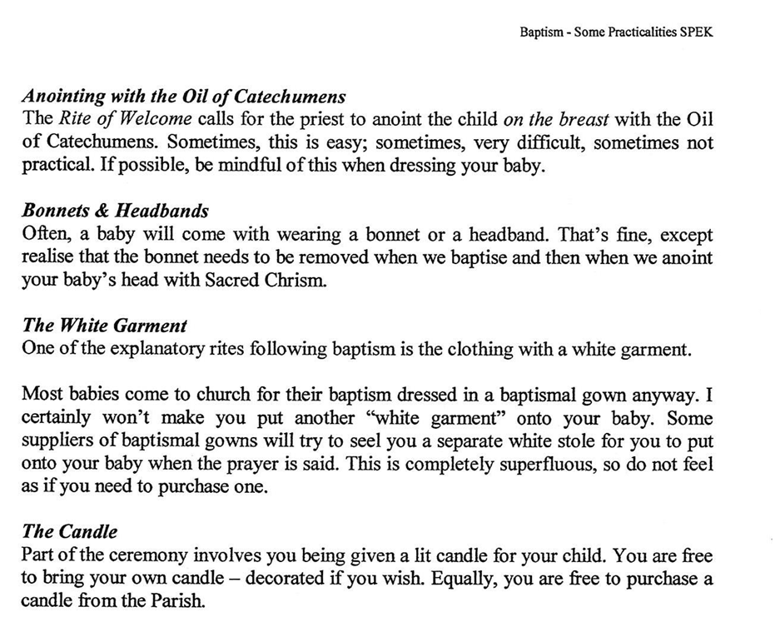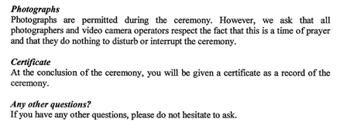

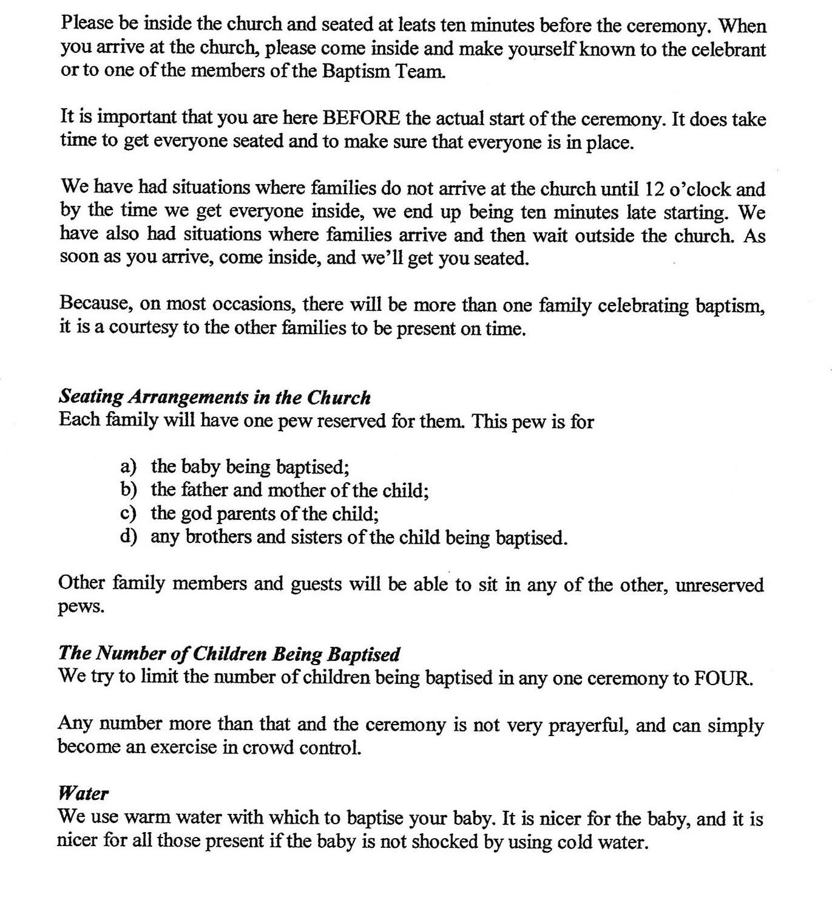

**Baptism—Some Practicalities**

***Parking***

**There is plenty of parking available to you and your guest in the Church Yard. Don’t rely just on street parking.**

***Time of Ceremony***

**Our Baptismal ceremonies here at St. Justin’s Parish are at 12 Midday.**